3GPP TS 29.507 V15.4.0 (2019-06)
Technical Specification
3rd Generation Partnership Project;
Technical Specification Group Core Network and Terminals;
5G System; Access and Mobility Policy Control Service;
Stage 3
(Release 15)


The present document has been developed within the 3rd Generation Partnership Project (3GPP TM) and may be further elaborated for the purposes of 3GPP.
The present document has not been subject to any approval process by the 3GPP Organizational Partners and shall not be implemented.
This Specification is provided for future development work within 3GPP only. The Organizational Partners accept no liability for any use of this Specification.
Specifications and Reports for implementation of the 3GPP TM system should be obtained via the 3GPP Organizational Partners' Publications Offices.

Keywords

3GPP
Postal address

3GPP support office address
650 Route des Lucioles - Sophia Antipolis
Valbonne - FRANCE
Tel.: +33 4 92 94 42 00 Fax: +33 4 93 65 47 16
Internet
http://www.3gpp.org
Copyright Notification
No part may be reproduced except as authorized by written permission.
The copyright and the foregoing restriction extend to reproduction in all media.

© 2019, 3GPP Organizational Partners (ARIB, ATIS, CCSA, ETSI, TSDSI, TTA, TTC).
All rights reserved.

UMTS™ is a Trade Mark of ETSI registered for the benefit of its members
3GPP™ is a Trade Mark of ETSI registered for the benefit of its Members and of the 3GPP Organizational Partners
LTE™ is a Trade Mark of ETSI registered for the benefit of its Members and of the 3GPP Organizational Partners
GSM® and the GSM logo are registered and owned by the GSM Association
Contents
Foreword 5
1 Scope 6
2 References 6
3 Definitions and abbreviations 7
3.1 Definitions 7
3.2 Abbreviations 7
4 Access and Mobility Policy Control Service 7
4.1 Service Description 7
4.1.1 Overview 7
4.1.2 Service Architecture 8
4.1.3 Network Functions 9
4.1.3.1 Policy Control Function (PCF) 9
4.1.3.2 NF Service Consumers 9
4.2 Service Operations 10
4.2.1 Introduction 10
4.2.2 Npcf_AMPolicyControl_Create Service Operation 10
4.2.2.1 General 10
4.2.2.2 Void 12
4.2.2.2.0 Void 12
4.2.2.2.1 Void 12
4.2.2.2.2 Void 12
4.2.2.3 AMF Access and Mobility Policy 12
4.2.2.3.1 Service Area Restriction 12
4.2.2.3.2 RFSP Index 13
4.2.3 Npcf_AMPolicyControl_Update Service Operation 13
4.2.3.1 General 13
4.2.3.2 Policy Control Request Triggers 14
4.2.3.3 Encoding of updated policy 15
4.2.4 Npcf_AMPolicyControl_UpdateNotify Service Operation 15
4.2.4.1 General 15
4.2.4.2 Policy update notification 15
4.2.4.3 Request for termination of the policy association 16
4.2.5 Npcf_AMPolicyControl_Delete Service Operation 17
5 Npcf_AMPolicyControl API 18
5.1 Introduction 18
5.2 Usage of HTTP 19
5.2.1 General 19
5.2.2 HTTP standard headers 19
5.2.2.1 General 19
5.2.2.2 Content type 19
5.2.3 HTTP custom headers 19
5.3 Resources 19
5.3.1 Resource Structure 19
5.3.2 Resource: AM Policy Associations 20
5.3.2.1 Description 20
5.3.2.2 Resource definition 20
5.3.2.3 Resource Standard Methods 20
5.3.2.3.1 POST 20
5.3.3 Resource: Individual AM Policy Association 21
5.3.3.1 Description 21
5.3.3.2 Resource definition 21
5.3.3.3 Resource Standard Methods 21
5.3.3.3.1 GET 21
5.3.3.3.2 DELETE 21
5.3.3.4 Resource Custom Operations 22
5.3.3.4.1 Overview 22
5.3.3.4.2 Operation: Update 22
5.3.3.4.2.1 Description 22
5.3.3.4.2.2 Operation Definition 22
5.4 Custom Operations without associated resources 23
5.5 Notifications 23
5.5.1 General 23
5.5.2 Policy Update Notification 23
5.5.2.1 Description 23
5.5.2.2 Operation Definition 23
5.5.3 Request for termination of the policy association 24
5.5.3.1 Description 24
5.5.3.2 Operation Definition 24
5.6 Data Model 24
5.6.1 General 24
5.6.2 Structured data types 25
5.6.2.1 Introduction 25
5.6.2.2 Type PolicyAssociation 26
5.6.2.3 Type PolicyAssociationRequest 27
5.6.2.4 Type PolicyAssociationUpdateRequest 28
5.6.2.5 Type PolicyUpdate 29
5.6.2.6 Type TerminationNotification 29
5.6.3 Simple data types and enumerations 29
5.6.3.1 Introduction 29
5.6.3.2 Simple data types 29
5.6.3.3 Enumeration: RequestTrigger 30
5.6.3.4 Enumeration: PolicyAssociationReleaseCause 30
5.7 Error handling 30
5.7.1 General 30
5.7.2 Protocol Errors 30
5.7.3 Application Errors 30
5.8 Feature negotiation 31
5.9 Security 31
Annex A (normative): OpenAPI specification 32
A.1 General 32
A.2 Npcf_AMPolicyControl API 32
Annex B (informative): Change history 38

Foreword
This Technical Specification has been produced by the 3rd Generation Partnership Project (3GPP).
The contents of the present document are subject to continuing work within the TSG and may change following formal TSG approval. Should the TSG modify the contents of the present document, it will be re-released by the TSG with an identifying change of release date and an increase in version number as follows:
Version x.y.z
where:
x the first digit:
1 presented to TSG for information;
2 presented to TSG for approval;
3 or greater indicates TSG approved document under change control.
y the second digit is incremented for all changes of substance, i.e. technical enhancements, corrections, updates, etc.
z the third digit is incremented when editorial only changes have been incorporated in the document.

1 Scope
The present specification provides the stage 3 definition of the Access and Mobility Policy Control Service (Npcf_AMPolicyControl) of the 5G System.
The stage 2 definition and procedures of the Access and Mobility Policy Control Service are contained in 3GPP TS 23.502 [3] and 3GPP TS 23.503 [4]. The 5G System Architecture is defined in 3GPP TS 23.501 [2].
Stage 3 call flows are provided in 3GPP TS 29.513 [7].
The Technical Realization of the Service Based Architecture and the Principles and Guidelines for Services Definition of the 5G System are specified in 3GPP TS 29.500 [5] and 3GPP TS 29.501 [6].
The Access and Mobility Policy Control Service is provided by the Policy Control Function (PCF). This service provides Access and Mobility Policies.

2 References
The following documents contain provisions which, through reference in this text, constitute provisions of the present document.
- References are either specific (identified by date of publication, edition number, version number, etc.) or non-specific.
- For a specific reference, subsequent revisions do not apply.
- For a non-specific reference, the latest version applies. In the case of a reference to a 3GPP document (including a GSM document), a non-specific reference implicitly refers to the latest version of that document in the same Release as the present document.
[1] 3GPP TR 21.905: "Vocabulary for 3GPP Specifications".
[2] 3GPP TS 23.501: "System Architecture for the 5G System; Stage 2".
[3] 3GPP TS 23.502: "Procedures for the 5G System; Stage 2".
[4] 3GPP TS 23.503: "Policy and Charging Control Framework for the 5G System; Stage 2".
[5] 3GPP TS 29.500: "5G System; Technical Realization of Service Based Architecture; Stage 3".
[6] 3GPP TS 29.501: "5G System; Principles and Guidelines for Services Definition; Stage 3".
[7] 3GPP TS 29.513: "5G System; Policy and Charging Control signalling flows and QoS parameter mapping; Stage 3".
[8] IETF RFC 7540: "Hypertext Transfer Protocol Version 2 (HTTP/2)".
[9] IETF RFC 8259: "The JavaScript Object Notation (JSON) Data Interchange Format".
[10] OpenAPI, "OpenAPI 3.0.0 Specification", https://github.com/OAI/OpenAPI-Specification/blob/master/versions/3.0.0.md.
[11] 3GPP TS 29.571: "5G System; Common Data Types for Service Based Interfaces; Stage 3".
[12] 3GPP TS 23.402: "Architecture enhancements for non-3GPP accesses".
[13] 3GPP TS 29.510: "5G System; Network Function Repository Services; Stage 3".
[14] 3GPP TS 29.518: "5G System; Access and Mobility Management Services; Stage 3".
[15] void.
[16] void.
[17] 3GPP TS 29.519: "5G System; Usage of the Unified Data Repository service for Policy Data, Application Data and Structured Data for Exposure; Stage 3".
[18] 3GPP TS 32.422: "Telecommunication management; Subscriber and equipment trace; Trace control and configuration management".
[19] 3GPP TS 33.501: "Security architecture and procedures for 5G system".
[20] IETF RFC 6749: "The OAuth 2.0 Authorization Framework".
[21] IETF RFC 7807: "Problem Details for HTTP APIs".
[22] 3GPP TR 21.900: "Technical Specification Group working methods".

3 Definitions and abbreviations

3.1 Definitions
For the purposes of the present document, the terms and definitions given in 3GPP TR 21.905 [1] and the following apply. A term defined in the present document takes precedence over the definition of the same term, if any, in 3GPP TR 21.905 [1].

3.2 Abbreviations
For the purposes of the present document, the abbreviations given in 3GPP TR 21.905 [1] and the following apply. An abbreviation defined in the present document takes precedence over the definition of the same abbreviation, if any, in 3GPP TR 21.905 [1].
AMF Access and Mobility Management Function
DNN Data Network Name
GPSI Generic Public Subscription Identifier
GUAMI Globally Unique AMF Identifier
JSON JavaScript Object Notation
NRF Network Repository Function
PCF Policy Control Function
PEI Permanent Equipment Identifier
PRA Presence Reporting Area
RFSP RAT Frequency Selection Priority
SUPI Subscription Permanent Identifier
UDM Unified Data Management
V-PCF Visited Policy Control Function

4 Access and Mobility Policy Control Service

4.1 Service Description

4.1.1 Overview
The Access and Mobility Policy Control Service, as defined in 3GPP TS 23.502 [3] and 3GPP TS 23.503 [4], is provided by the Policy Control Function (PCF).
This service provides AMF access control and mobility management related policies to the AMF and offers the following functionalities:
- policy creation based on a request from the AMF during UE registration;
- notification of the AMF of the updated policies which are subscribed; and
- deletion of the policy context for a UE.

4.1.2 Service Architecture
The 5G System Architecture is defined in 3GPP TS 23.501 [2]. The Policy and Charging related 5G architecture is also described in 3GPP TS 29.513 [7].
The Access and Mobility Policy Control Service (Npcf_AMPolicyControl) is part of the Npcf service-based interface exhibited by the Policy Control Function (PCF).
The known consumer of the Npcf_AMPolicyControl service is the Access and Mobility Management Function (AMF).
The AMF accesses the Access and Mobility Policy Control Service at the PCF via the N15 Reference point. In the roaming scenario, the N15 reference point is located between the V-PCF in the visited network and the AMF.
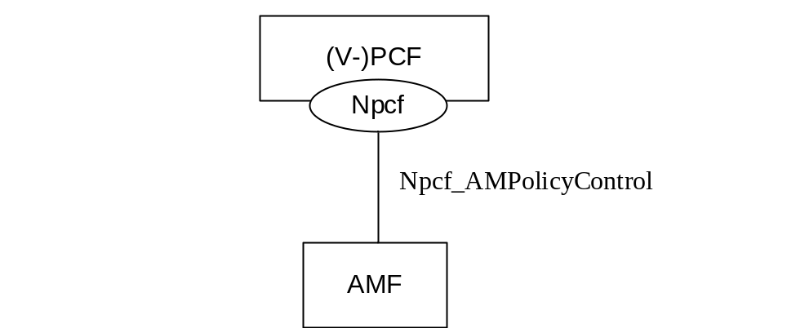
Figure 4.1.2-1: Reference Architecture for the Npcf_AMPolicyControl Service; SBI representation
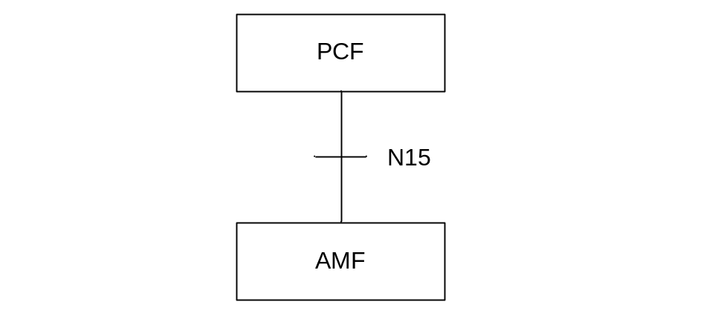
Figure 4.1.2-2: Non-roaming Reference Architecture for the Npcf_AMPolicyControl Service; reference point representation
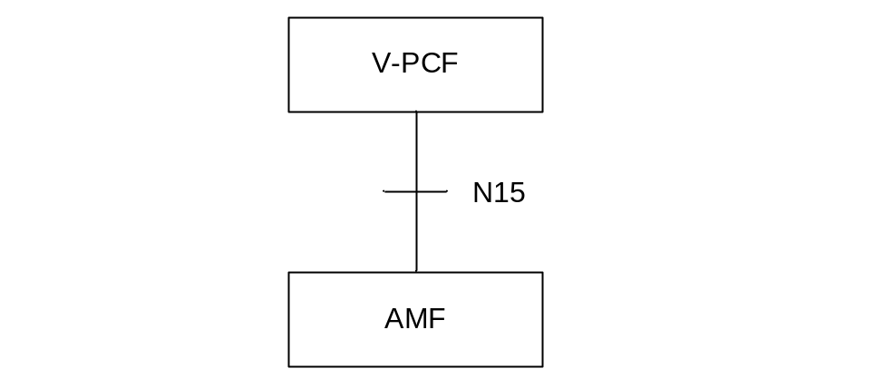
Figure 4.1.3-2: Roaming reference Architecture for the Npcf_AMPolicyControl Service; reference point representation

4.1.3 Network Functions

4.1.3.1 Policy Control Function (PCF)
The Policy Control Function (PCF):
- Supports unified policy framework to govern network behaviour; and
- Provides Access and Mobility Management related policies to the AMF that enforces them.
In the roaming scenario, the Visited Policy Control Function (V-PCF) provides the functions described in this subclause towards the visited network.

4.1.3.2 NF Service Consumers
The Access and Mobility Management function (AMF) provides:
- Registration management;
- Connection management;
- Reachability management; and
- Mobility Management.

4.2 Service Operations

4.2.1 Introduction
Table 4.2.1-1: Operations of the Npcf_AMPolicyControl Service
Service operation name | Description | Initiated by
Npcf_AMPolicyControl_Create | Creates an AM Policy Association and provides corresponding policies to the NF consumer. | NF consumer (AMF)
Npcf_AMPolicyControl_Update | Updates of an AM Policy Association and provides corresponding policies to the NF consumer when the policy control request trigger is met or the AMF is relocated due to the UE mobility and the old PCF is selected. | NF consumer (AMF)
Npcf_AMPolicyControl_UpdateNotify | Provides updated policies to the NF consumer. | PCF (V-PCF in roaming case)
Npcf_AMPolicyControl_Delete | Provides means for the NF consumer to delete the AM Policy Association. | NF consumer (AMF)

4.2.2 Npcf_AMPolicyControl_Create Service Operation

4.2.2.1 General
The procedure in the present subclause is applicable when the NF service consumer creates an AM policy association when the UE registers to the network, and when the the AMF is relocated (between the different AMF sets) and the new AMF selects a new PCF. The procedure for the case where the AMF is relocated and the new AMF selects the old PCF is defined in subclause 4.2.3.1.
The creation of an AM policy association only applies for normally registered UEs, i.e., it does not apply for Emergency Registered UEs.
Figure 4.2.2.1-1 illustrates the creation of a policy association.
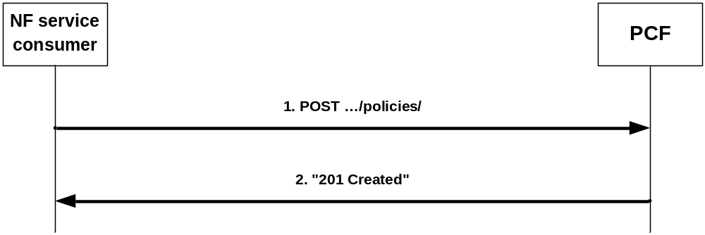
Figure 4.2.2.1-1: Creation of a policy association
When a UE registers and a UE context is being established, the AMF can obtain Service Area Restrictions, RFSP index, and GPSI from the UDM during the update location procedure and shall decide based on local policies whether to request policies from the PCF.
To request policies from the PCF, the NF service consumer (e.g. AMF) shall send an HTTP POST request with: "{apiRoot}/npcf-am-policy-control/v1/policies/" as Resource URI and the PolicyAssociationRequest data structure as request body that shall include:
- Notification URI encoded as "notificationUri" attribute; and
- SUPI encoded as "supi" attribute,
and that shall include when available:
- GPSI encoded as "gpsi" attribute;
- Access type encoded as "accessType" attribute;
- Permanent Equipment Identifier (PEI) encoded as "pei" attribute;
- User Location Information encoded as "userLoc" attribute;
- UE Time Zone encoded as "timeZone" attribute;
- Serving PLMN Identifier encoded as "servingPlmn" attribute;
- RAT type encoded as "ratType" attribute;
- Service Area Restriction s (see subclause 4.2.2.3.1) derived from the Service Area Restrictions obtained from the UDM by mapping any service areas denoted by geographical information into Tracking Area Identities (TAIs) and encoded as "servAreaRes" attribute;
- RFSP index (see subclause 4.2.2.3.2) as obtained from the UDM encoded as "rfsp" attribute;
- A list of Internal Group Identifiers encoded as "groupIds" attribute;
- if the NF service consumer is an AMF, the GUAMI encoded as "guami" attribute;
- if the NF service consumer is an AMF, the name of a service produced by the AMF that expects to receive information within Npcf_AMPolicyControl_UpdateNotify service operation encoded as "serviceName" attribute;
- Alternate or backup IPv4 Address(es) where to send Notifications encoded as "altNotifIpv4Addrs" attribute;
- Alternate or backup IPv6 Address(es) where to send Notifications encoded as "altNotifIpv6Addrs" attribute; and
- trace control and configuration parameters information encoded as "traceReq" attribute.
Upon the reception of the HTTP POST request, the PCF:
- shall assign a policy association ID;
- shall determine the applicable policy (taking into consideration and optionally modifying possibly received Service Area Restrictions and/or RFSP index);
- for the succesfull case shall send a HTTP "201 Created" response with the URI for the created resource in the "Location" header field
NOTE: The assigned policy association ID is part of the URI for the created resource and is thus associated with the SUPI.
and the the PolicyAssociation data type as body including:
- conditionally AMF Access and Mobility Policy (see subclause 4.2.2.3), i.e.:
a) if the PCF received the "servAreaRes" in the request, Service Area Restrictions encoded as "servAreaRes" attribute; and/or
b) if the PCF received the "rfsp" attributes in the request, RAT Frequency Selection Priority (RFSP) Index encoded as "rfsp" attribute;
- optionally one or several of the following Policy Control Request Trigger(s) encoded as "triggers" attribute (see subclause 4.2.3.2):
a) Location change (tracking area); and
b) Change of UE presence in PRA; and
- if the Policy Control Request Trigger "Change of UE presence in PRA" is provided, the presence reporting areas for which reporting is required encoded as "pras" attribute;
- if errors occur when processing the HTTP POST request, shall apply error handling procedures as specified in subclause 5.7 and according to the following provisions:
- if the user information received within the "supi" attribute is unknown, the PCF shall reject the request and include in an HTTP "400 Bad Request" response message the "cause" attribute of the ProblemDetails data structure set to "USER_UNKNOWN";
- if the PCF is, due to incomplete, erroneous or missing information in the request not able to provision an AM policy decision, the PCF may reject the request and include in an HTTP "400 Bad Request" response message the "cause" attribute of the ProblemDetails data structure set to "ERROR_REQUEST_PARAMETERS".
If the PCF received an GUAMI, the PCF may subscribe to GUAMI changes using the AMFStatusChange service operation of the Namf_Communication service specified in 3GPP TS 29.518 [14], and it may use the Nnrf_NFDiscovery Service specified in 3GPP TS 29.510 [13] (using the obtained GUAMI and possibly service name) to query the other AMFs within the AMF set.
If the PCF received a "traceReq" attribute, it shall perform trace procedures as defined in 3GPP TS 32.422 [18].

4.2.2.2 Void

4.2.2.2.0 Void

4.2.2.2.1 Void

4.2.2.2.2 Void

4.2.2.3 AMF Access and Mobility Policy

4.2.2.3.1 Service Area Restriction
If service area restrictions are enabled, the Service Area Restriction information is encoded using the "ServiceArea Restriction" data type defined in 3GPP TS 29.571 [11] and consists of:
- either:
a) the maximum number of allowed TAs that can be traversed encoded as "maxNumOfTAs" attribute; and/or
b) both of:
(i) a list of allowed Tracking Area Identities (TAIs) encoded as "tacs" attributes within the "areas" attribute; and
(ii) the "restrictionType" attribute set to "ALLOWED_AREAS";
- or:
a) a list of not allowed Tracking Area Identities (TAIs) encoded as "tacs" attributes within the "areas" attribute; and
b) the "restrictionType" attribute set to "NOT_ALLOWED_AREAS".
When the "restrictionType" attribute is set to "NOT_ALLOWED_AREAS", the "maxNumOfTAs" attribute shall not be present.
When for an allowed area both, "maxNumOfTAs" and "areas" attributes are present, the "maxNumOfTAs" attribute represents the upper limit of the limited allowed area. The AMF may add any not yet visited tracking areas to the allowed area represented by the "areas" attribute until the total number of TAs reaches the "maxNumOfTAs" attribute value.
NOTE: The "maxNumOfTAs" attribute value cannot be lower than the number of TAIs included in the "tacs" attribute.
When the authorized service area restrictions result in an unlimited set of tracking areas, the PCF shall include an empty "servAreaRes" attribute.

4.2.2.3.2 RFSP Index
The RFSP Index is an index referring to a UE information used locally by the Access Network in order to apply specific radio resource management strategies. It shall be encoded using the RfspIndex data type defined in 3GPP TS 29.571 [11].

4.2.3 Npcf_AMPolicyControl_Update Service Operation

4.2.3.1 General
The procedure in the present subclause is applicable when the NF service consumer modifies an existing AM policy association (including the case where the AMF is relocated and the new AMF selects to maintain the policy association with the old PCF and to update the Notification URI).
Figure 4.2.3.1-1 illustrates the update of a policy association.
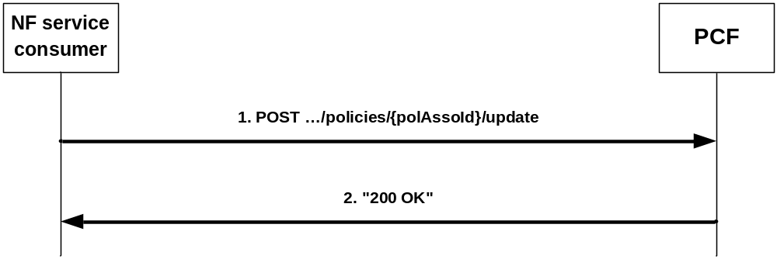
Figure 4.2.3.1-1: Update of a policy association
The AMF as NF service consumer invokes this procedure when a policy control request trigger (see subclause 4.2.3.2) occurs. When the Service Area restriction change trigger or the RFSP index change trigger occur, the AMF shall always invoke the procedure. When the location change trigger or the change of UE presence in PRA trigger occurs, the AMF shall only invoke the procedure if the PCF has subscribed to that event trigger.
If an AMF knows by implementation specific means that the UE context has been transferred to an AMF with another GUAMI within the AMF set, it may also invoke this procedure to update the Notification URI.
NOTE 1: Either the old or the new AMF can invoke this procedure.
During the AMF relocation, if the new AMF received the resource URI of the individual AM Policy from the old AMF and selects the old PCF, the new AMF shall also invoke this procedure to update the Notification URI. The new AMF may also update the alternate or backup IP addresses.
To request policies from the PCF and/or to update the Notification URI, and/or to update the trace control configuration, and/or to request the termination of trace, the NF Service Consumer (e.g. AMF) shall request the update of an AM Policy Association by providing relevant parameters about the UE context by sending an HTTP POST request with "{apiRoot}/npcf-am-policy-control/v1/policies/{polAssoId}/update" as Resource URI and the PolicyAssociationUpdateRequest data structure as request body that shall include:
- at least one of the following:
1. a new Notification URI encoded in the "notificationUri" attribute; and/or
2. observed Policy Control Request Trigger(s) (see subclause 4.2.3.2) encoded as "triggers" attribute;
3. if a Service Area restriction change occurred, the Service Area Restrictions (see subclause 4.2.2.3.1) as obtained from the UDM encoded as "servAreaRes" attribute;
4. if a RFSP index change occurred, the RFSP index (see subclause 4.2.2.3.2) as obtained from the UDM encoded as "rfsp" attribute;
5. if a UE location change occurred, the UE location encoded as "userLoc" attribute;
6. if the Policy Control Request Trigger "Change of UE presence in PRA" is provided, the presence reporting areas for which reporting was requested and the status has changed encoded as "praStatuses" attribute.
7. if the trace control configuration needs to be updated, trace control and configuration parameters information encoded as "traceReq" attribute;and
8. if trace needs to be terminated, the "traceReq" attribute set to the Null value;
9. for AMF relocation scenarios, if available, alternate or backup IPv4 Address(es) where to send Notifications encoded as "altNotifIpv4Addrs" attribute; and/or
10. for AMF relocation scenarios, if available, alternate or backup IPv6 Address(es) where to send Notifications encoded as "altNotifIpv6Addrs" attribute.
NOTE 2: An alternate NF service consumer than the one that requested the generation of the subscription resource can send the request. For instance, an AMF as service consumer can change.
Upon the reception of the HTTP POST request, the PCF:
- shall update the corresponding individual AM Policy resource based on the information provided by the AMF;
- shall determine the applicable policy based on local policy;
- for the succesfull case shall send a HTTP "200 OK" response with the PolicyUpdate data type as body with possible updates for that applicable policy and Policy Control Request Trigger(s) encoded as described in subclause 4.2.3.3 and according to the following provisions:
a) if the PCF received the "servAreaRes" in the request, Service Area Restrictions encoded as "servAreaRes" attribute; and/or
b) if the PCF received the "rfsp" attributes in the request, RAT Frequency Selection Priority (RFSP) Index encoded as "rfsp" attribute;
- if errors occur when processing the HTTP POST request, shall apply error handling procedures as specified in subclause 5.7 and according to the following provisions:
- if the PCF is, due to incomplete, erroneous or missing information in the request not able to provision an AM policy decision, the PCF may reject the request and include in an HTTP "400 Bad Request" response message the "cause" attribute of the ProblemDetails data structure set to "ERROR_REQUEST_PARAMETERS".
If the PCF received a "traceReq" attribute, it shall perform trace procedures as defined in 3GPP TS 32.422 [18].
If the AMF received the request of removal of Service Area Restrictions and/or RFSP from the UDM, the AMF shall remove the authorized Service Area Restrictions and/or RFSP provisioned by the PCF and apply the configured Service Area Restrictions and/or RFSP at the AMF to the UE without the interaction with the PCF.

4.2.3.2 Policy Control Request Triggers
The following Policy Control Request Triggers are defined (see subclause 6.1.2.5 of 3GPP TS 23.503 [4]):
- "LOC_CH", i.e. location change (tracking area): the tracking area of the UE has changed;
- "PRA_CH", i.e. change of UE presence in PRA: the UE is entering/leaving a Presence Reporting Area;
- "SERV_AREA _CH", i.e. Service Area Restriction change: the UDM notifies the AMF that the subscribed service area restriction information has changed; and
- "RFSP_CH", i.e. RFSP index change: the UDM notifies the AMF that the subscribed RFSP index has changed.

4.2.3.3 Encoding of updated policy
Updated policies shall be encoded within the PolicyUpdate data type that may include:
- AMF Access and Mobility Policy (see subclause 4.2.2.3) Service Area Restriction encoded as "servAreaRes" attribute;
- AMF Access and Mobility Policy (see subclause 4.2.2.3) RFSP Index encoded as "rfsp" attribute;
- updated Policy Control Request Trigger(s) (see subclause 4.2.3.2) encoded as "triggers" attribute i.e.:
1) either a new complete list of applicable Policy Control Request Trigger(s) including one or several of the following:
a) Location change (tracking area);
b) Change of UE presence in PRA; or
2) a "NULL" value to request the removal of all previously installed Policy Control Request Trigger(s); and
- if the Policy Control Request Trigger "Change of UE presence in PRA" is provided or if that trigger was already set but the requested presence reporting areas need to be changed, the presence reporting areas for which reporting is required encoded as "pras" attribute encoded as follows:
a) A new entry shall be added by supplying a new identifier as key and the corresponding PresenceInfo data type instance with complete contents as value as an entry within the map.
b) An existing entry shall be modified by supplying the existing identifier as key and the PresenceInfo data type instance with complete contents as value as an entry within the map.
c) An existing entry shall be deleted by supplying the existing identifier as key and "NULL" as value as an entry within the map.
d) For an unmodified entry, no entry needs to be provided within the map; and
- if the Policy Control Request Trigger "Change of UE presence in PRA" is removed, the presence reporting areas for which reporting was required shall be removed by providing the "pras" attribute with "NULL" as value.

4.2.4 Npcf_AMPolicyControl_UpdateNotify Service Operation

4.2.4.1 General
The PCF may decide to update policies or to request the termination of the policy association and shall then use an Npcf_AMPolicyControl_UpdateNotify service operation.
The following procedures using the Npcf_AMPolicyControl_UpdateNotify service operation are supported:
- policy update notification; and
- request for termination of the policy association.

4.2.4.2 Policy update notification
Figure 4.2.4.2-1 illustrates the policy update notification.
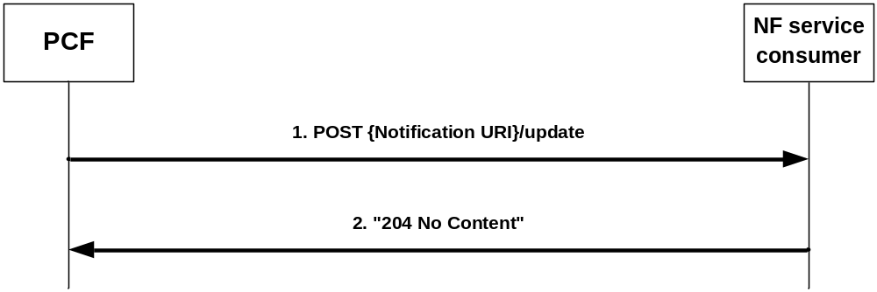
Figure 4.2.4.2-1: policy update notification
The PCF may decide to update policies and shall then send an HTTP POST request with "{Notification URI}/update" as URI (where the Notification URI was previously supplied by the NF service consumer) and the PolicyUpdate data structure as request body encoded as described in subclause 4.2.3.3.
Upon the reception of the HTTP POST request, the NF service consumer:
- shall enforce the received updated policy;
- shall either send a HTTP "204 No Content" response indicating the success of the enforcement or an appropriate failure response; and
- if errors occur when processing the HTTP POST request, shall apply error handling procedures as specified in subclause 5.7.
If the AMF as NF service consumer is not able to handle the notification but knows by implementation specific means that another AMF is able to handle the notification, it shall reply with an HTTP "307 temporary redirect" error response pointing to the URI of the new AMF. If the AMF is not able to handle the notification but another unknown AMF could possibly handle the notification, it shall reply with an HTTP "404 Not found" error response.
If the PCF receives a "307 temporary redirect" response, the PCF shall use this URL as Notification URL in subsequent communication and shall resend the failed policy update notification request to that URL.
If the PCF becomes aware that a new AMF is requiring notifications (e.g. via the "404 Not found" response or via Namf_Communication service AMFStatusChange Notifications, see 3GPP TS 29.518 [14], or via link level failures), and the PCF knows alternate or backup IPv4 or IPv6 Addess(es) where to send Notifications (e.g. via "altNotifIpv4Addrs" or "altNotifIpv6Addrs" attributes received when the policy association was created or via AMFStatusChange Notifications, or via the Nnrf_NFDiscovery Service specified in 3GPP TS 29.510 [13] (using the service name and GUAMI obtained during the creation of the subscription) to query the other AMFs within the AMF set), the PCF shall exchange the authority part of the corresponding Notification URL with one of those addresses and shall use that URL in subsequent communication. If the PCF received a "404 Not found" response, the PCF should resend the failed policy update notification request to that URL.

4.2.4.3 Request for termination of the policy association
Figure 4.2.4.3-1 illustrates the request for a termination of the policy association.
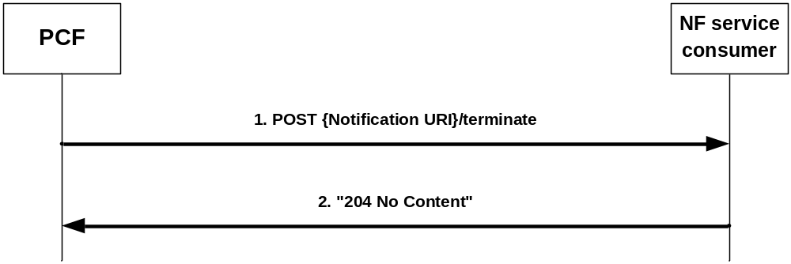
Figure 4.2.4.3-1: request for a termination of the policy association
The PCF may to request the termination of the policy association and shall then send an HTTP POST request with "{Notification URI}/terminate" as URI (where the Notification URI was previously supplied by the NF service consumer) and the TerminationNotification data structure as request body that shall include:
- the policy association ID encoded as "polAssoId" attribute; and
- the cause why the PCF requests the termination of the policy association encoded as "cause" attribute.
Upon the reception of the HTTP POST request, the NF service consumer:
- shall either send a HTTP "204 No Content" responsefor the succesfull processing of the HTTP POST request or an appropriate failure response; and
- if errors occur when processing the HTTP POST request, shall apply error handling procedures as specified in subclause 5.7.
After the succesfull processing of the HTTP POST request, the NF service consumer shall remove the context related to the policy association but still apply the provisioned AM policies to the UE and invoke the Npcf_AMPolicyControl_Delete Service Operation defined in subclause 4.2.5 to terminate the policy association.
If the AMF as NF service consumer is not able to handle the notification but knows by implementation specific means that another AMF is able to handle the notification, it shall reply with an HTTP "307 temporary redirect" error response pointing to the URI of the new AMF. If the AMF is not able to handle the notification but another unknown AMF could possibly handle the notification, it shall reply with an HTTP "404 Not found" error response.
If the PCF receives a "307 temporary redirect" response, the PCF shall use this URL as Notification URL in subsequent communication and shall resend the failed request for termination of the policy association to that URL.
If the PCF becomes aware that a new AMF is requiring notifications (e.g. via the "404 Not found" response or via Namf_Communication service AMFStatusChange Notifications, see 3GPP TS TS 29.518 [14], or via link level failures), and the PCF knows alternate or backup IPv4 or IPv6 Addess(es) where to send Notifications (e.g. via "altNotifIpv4Addrs" or "altNotifIpv6Addrs" attributes received when the policy association was created or via AMFStatusChange Notifications, or via the Nnrf_NFDiscovery Service specified in 3GPP TS 29.510 [13] (using the service name and GUAMI obtained during the creation of the subscription) to query the other AMFs within the AMF set), the PCF shall exchange the authority part of the corresponding Notification URL with one of those addresses and shall use that URL in subsequent communication. If the PCF received a "404 Not found" response, the PCF should resend the failed request for termination of the policy association to that URL.

4.2.5 Npcf_AMPolicyControl_Delete Service Operation
Figure 4.2.5-1 illustrates the deletion of a policy association.
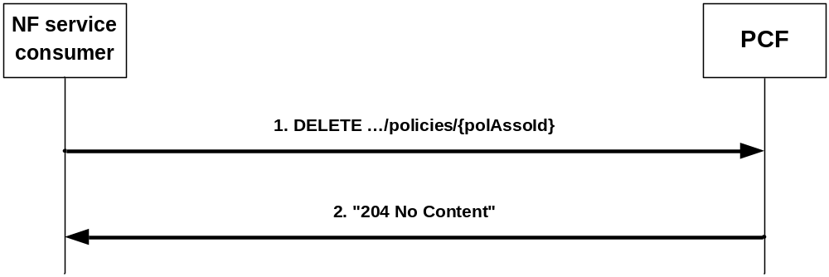
Figure 4.2.5-1: Deletion of a policy association
The AMF as NF service consumer requests that the policy association is deleted when the corresponding UE context is terminated, e.g. during UE de-registration from the network.
During the AMF relocation, the old AMF shall invoke this procedure when:
- the resource URI of the "Individual AM Policy Association" resource is not transferred to the new AMF; or
- the new AMF informs the old AMF that the "Individual AM Policy Association" resource is not being reused (i.e. the old PCF is not being reused).
To request that the policy association is deleted, the NF service consumer (e.g. AMF) shall send an HTTP DELETE request with "{apiRoot}/npcf-am-policy-control/v1/policies/{polAssoId}" as Resource URI.
Upon the reception of the HTTP DELETE request, the PCF shall:
- delete the policy association;
- send either an HTTP "204 No Content" response indicating the success of the deletion or an appropriate failure response; and
- if errors occur when processing the HTTP DELETE request, apply error handling procedures as specified in subclause 5.7.

5 Npcf_AMPolicyControl API

5.1 Introduction
The Access and Mobility Policy Control Service shall use the Npcf_AMPolicyControl API.
The request URI used in HTTP request from the NF service consumer towards the PCF shall have the structure defined in subclause 4.4.1 of 3GPP TS 29.501 [6], i.e.:
{apiRoot}/{apiName}/{apiVersion}/{apiSpecificResourceUriPart}
with the following components:
- The {apiRoot} shall be set as described in 3GPP TS 29.501 [6].
- The {apiName} shall be "npcf-am-policy-control".
- The {apiVersion} shall be "v1".
- The {apiSpecificResourceUriPart} shall be set as described in subclause 5.3.

5.2 Usage of HTTP

5.2.1 General
HTTP/2, IETF RFC 7540 [8], shall be used as specified in clause 5 of 3GPP TS 29.500 [5].
HTTP/2 shall be transported as specified in subclause 5.3 of 3GPP TS 29.500 [5].
The OpenAPI [10] specification of HTTP messages and content bodies for the Npcf_AMPolicyControl is contained in Annex A.

5.2.2 HTTP standard headers

5.2.2.1 General
See subclause 5.2.2 of 3GPP TS 29.500 [5] for the usage of HTTP standard headers.

5.2.2.2 Content type
JSON, IETF RFC 8259 [9], shall be used as content type of the HTTP bodies specified in the present specification as specified in subclause 5.4 of 3GPP TS 29.500 [5] The use of the JSON format shall be signalled by the content type "application/json".
"Problem Details" JSON object shall be used to indicate additional details of the error in a HTTP response body and shall be signalled by the content type "application/problem+json", as defined in IETF RFC 7807 [21].

5.2.3 HTTP custom headers
The mandatory HTTP custom header fields specified in subclause 5.2.3.2 of 3GPP TS 29.500 [5] shall be applicable

5.3 Resources

5.3.1 Resource Structure
x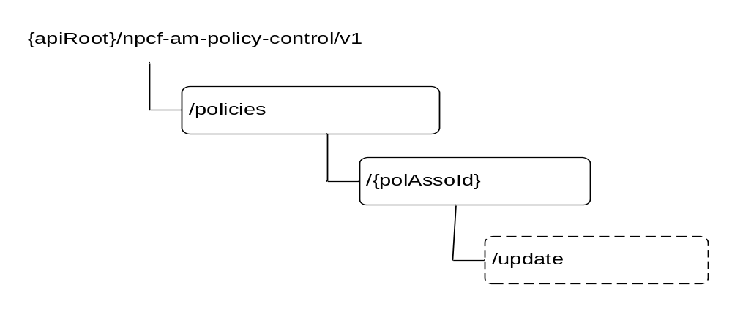
Figure 5.3.1-1: Resource URI structure of the Npcf_AMPolicyControl API
Table 5.3.1-1 provides an overview of the resources and applicable HTTP methods.
Table 5.3.1-1: Resources and methods overview
Resource name | Resource URI | HTTP method or custom operation | Description
AM Policy Associations | {apiRoot}/  npcf-am-policy-control/  v1/policies/ | POST | Create a new Individual AM Policy Association resource.
Individual AM Policy Association | {apiRoot}  /npcf-am-policy-control/  v1/policies/  {polAssoId} | GET | Read the Individual AM Policy Association resource.
Individual AM Policy Association |  | DELETE | Delete the Individual AM Policy Association resource.
Individual AM Policy Association | {apiRoot}  /npcf-am-policy-control/  v1/policies/  {polAssoId}/update | update (POST) | Report observed event trigger and obtain updated policies.

5.3.2 Resource: AM Policy Associations

5.3.2.1 Description
This resource represents a collection of Individual AM policy Associations.

5.3.2.2 Resource definition
Resource URI: {apiRoot}/npcf-am-policy-control/v1/policies/
This resource shall support the resource URI variables defined in table 5.3.2.2-1.
Table 5.3.2.2-1: Resource URI variables for this resource
Name | Definition
apiRoot | See subclause 5.1

5.3.2.3 Resource Standard Methods

5.3.2.3.1 POST
This method shall support the URI query parameters specified in table 5.3.2.3.1-1.
Table 5.3.2.3.1-1: URI query parameters supported by the POST method on this resource
Name | Data type | P | Cardinality | Description
n/a

This method shall support the request data structures specified in table 5.3.2.3.1-2 and the response data structures and response codes specified in table 5.3.2.3.1-3.
Table 5.3.2.3.1-2: Data structures supported by the POST Request Body on this resource
Data type | P | Cardinality | Description
PolicyAssociationRequest | M | 1 | Input parameters for the creation of a policy association.

Table 5.3.2.3.1-3: Data structures supported by the POST Response Body on this resource
Data type | P | Cardinality | Response codes | Description
PolicyAssociation | M | 1 | 201 Created | Policy association was created and policies are being provided.
NOTE: The mandatory HTTP error status codes for the POST method listed in Table 5.2.7.1-1 of 3GPP TS 29.500 [5] also apply.

5.3.3 Resource: Individual AM Policy Association

5.3.3.1 Description
This document resource represents an individual AM policy association.

5.3.3.2 Resource definition
Resource URI: {apiRoot}/npcf-am-policy-control/v1/policies/{polAssoId}
This resource shall support the resource URI variables defined in table 5.3.2.2-1.
Table 5.3.2.2-1: Resource URI variables for this resource
Name | Definition
apiRoot | See subclause 5.1.
polAssoId | Identifier of a policy association.

5.3.3.3 Resource Standard Methods

5.3.3.3.1 GET
This method shall support the URI query parameters specified in table 5.3.2.3.1-1.
Table 5.3.3.3.1-1: URI query parameters supported by the GET method on this resource
Name | Data type | P | Cardinality | Description
n/a

This method shall support the request data structures specified in table 5.3.2.3.1-2 and the response data structures and response codes specified in table 5.3.2.3.1-3.
Table 5.3.3.3.1-2: Data structures supported by the GET Request Body on this resource
Data type | P | Cardinality | Description
n/a

Table 5.3.3.3.1-3: Data structures supported by the GET Response Body on this resource
Data type | P | Cardinality | Response codes | Description
PolicyAssociation | M | 1 | 200 OK
NOTE: The mandatory HTTP error status codes for the GET method listed in Table 5.2.7.1-1 of 3GPP TS 29.500 [5] also apply.

5.3.3.3.2 DELETE
This method shall support the URI query parameters specified in table 5.3.3.3.2-1.
Table 5.3.3.3.2-1: URI query parameters supported by the DELETE method on this resource
Name | Data type | P | Cardinality | Description
n/a

This method shall support the request data structures specified in table 5.3.3.3.2-2 and the response data structures and response codes specified in table 5.3.3.3.2-3.
Table 5.3.3.3.2-2: Data structures supported by the DELETE Request Body on this resource
Data type | P | Cardinality | Description
n/a

Table 5.3.3.3.2-3: Data structures supported by the DELETE Response Body on this resource
Data type | P | Cardinality | Response codes | Description
n/a |  |  | 204 No Content | The policy association was successfully deleted.
NOTE: The mandatory HTTP error status codes for the DELETE method listed in Table 5.2.7.1-1 of 3GPP TS 29.500 [5] also apply.

5.3.3.4 Resource Custom Operations

5.3.3.4.1 Overview
Table 5.3.3.4.1-1: Custom operations
Custom operation URI | Mapped HTTP method | Description
{apiRoot}  /npcf-am-policy-control/v1/  policies/  {polAssoId}/update | POST | Report observed event trigger and obtain updated policies.

5.3.3.4.2 Operation: Update

5.3.3.4.2.1 Description
The update custom operation allows an NF service consumer to report the occurrence on a police request trigger and to obtain related updated policies.

5.3.3.4.2.2 Operation Definition
This operation shall support the request data structures specified in table 5.3.3.4.2.2-1 and the response data structure and response codes specified in table 5.3.3.4.2.2-2.
Table 5.3.3.4.2.2-1: Data structures supported by the POST Request Body on this resource
Data type | P | Cardinality | Description
PolicyAssociationUpdateRequest | M | 1 | Describes the observed event trigger(s).

Table 5.3.3.4.2.2-2: Data structures supported by the POST Response Body on this resource
Data type | P | Cardinality | Response codes | Description
PolicyUpdate | M | 1 | 200 OK | Describes updated policies.
NOTE: The mandatory HTTP error status codes for the POST method listed in Table 5.2.7.1-1 of 3GPP TS 29.500 [5] also apply.

5.4 Custom Operations without associated resources
None.

5.5 Notifications

5.5.1 General
Table 5.5.1-1: Notifications
Custom operation URI | Mapped HTTP method | Description
{Notification URI}/update | POST | Policy Update Notification.
{Notification URI}/terminate | POST | Request for termination of the policy association.

5.5.2 Policy Update Notification

5.5.2.1 Description
This notification is used by the PCF to provide updates of access and mobility policies to the NF service consumer.

5.5.2.2 Operation Definition
This operation shall support the request data structures specified in table 5.5.2.2-1 and the response data structure and response codes specified in table 5.5.2.2-2.
Table 5.5.2.2-1: Data structures supported by the POST Request Body on this resource
Data type | P | Cardinality | Description
PolicyUpdate | M | 1 | Updated policies.

Table 5.5.2.2-2: Data structures supported by the POST Response Body on this resource
Data type | P | Cardinality | Response codes | Description
n/a |  |  | 204 No Content | The policies were successfully updated.
n/a |  |  | 307 temporary redirect | The NF service consumer shall generate a Location header field containing a URI pointing to another NF service consumer to which the notification should be send.
ProblemDetails | M | 1 | 404 Not Found | The NF service consumer can use this response when the notification can be sent to another unknown host.
NOTE: The mandatory HTTP error status codes for the POST method listed in Table 5.2.7.1-1 of 3GPP TS 29.500 [5] also apply.

5.5.3 Request for termination of the policy association

5.5.3.1 Description
This notification is used by the PCF to request the termination of a policy association.

5.5.3.2 Operation Definition
This operation shall support the request data structures specified in table 5.5.3.2-1 and the response data structure and response codes specified in table 5.5.3.2-2.
Table 5.5.3.2-1: Data structures supported by the POST Request Body on this resource
Data type | P | Cardinality | Description
TerminationNotification | M | 1 | Request to terminate the policy association.

Table 5.5.3.2-2: Data structures supported by the POST Response Body on this resource
Data type | P | Cardinality | Response codes | Description
n/a |  |  | 204 No Content | The request for policy association termination was received.
n/a |  |  | 307 temporary redirect | The NF service consumer shall generate a Location header field containing a different URI pointing to another NF service consumer to which the notification should be send.
ProblemDetails | M | 1 | 404 Not Found | The NF service consumer can use this response when the notification can be sent to another unknown host.
NOTE: The mandatory HTTP error status codes for the POST method listed in Table 5.2.7.1-1 of 3GPP TS 29.500 [5] also apply.

5.6 Data Model

5.6.1 General
This subclause specifies the application data model supported by the API.
Table 5.6.1-1 specifies the data types defined for the Npcf_AMPolicyControl service based interface protocol.
Table 5.6.1-1: Npcf_AMPolicyControl specific Data Types
Data type | Section defined | Description | Applicability
PolicyAssociation | 5.6.2.2 | Description of a policy association that is returned by the PCF when a policy Association is created, or read.
PolicyAssociationReleaseCause | 5.6.3.4 | The cause why the PCF requests the termination of the policy association.
PolicyAssociationRequest | 5.6.2.3 | Information that NF service consumer provides when requesting the creation of a policy association.
PolicyAssociationUpdateRequest | 5.6.2.4 | Information that NF service consumer provides when requesting the update of a policy association.
PolicyUpdate | 5.6.2.5 | Updated policies that the PCF provides in a notification or in the reply to an Update Request.
RequestTrigger | 5.6.3.3 | Enumeration of possible Request Triggers.
TerminationNotification | 5.6.2.6 | Request to terminate a policy Association that the PCF provides in a notification.

Table 5.6.1-2 specifies data types re-used by the Npcf_AMPolicyControl service based interface protocol from other specifications, including a reference to their respective specifications and when needed, a short description of their use within the Npcf_AMPolicyControl service based interface.
Table 5.6.1-2: Npcf_AMPolicyControl re-used Data Types
Data type | Reference | Comments | Applicability
AccessType | 3GPP TS 29.571 [11]
Gpsi | 3GPP TS 29.571 [11] | Generic Public Subscription Identifier
GroupId | 3GPP TS 29.571 [11]
Guami | 3GPP TS 29.571 [11] | Globally Unique AMF Identifier
Ipv4Addr | 3GPP TS 29.571 [11]
Ipv6Addr | 3GPP TS 29.571 [11]
NetworkId | 3GPP TS 29.571 [11]
Pei | 3GPP TS 29.571 [11] | Permanent Equipment Identifier
PresenceInfo | 3GPP TS 29.571 [11] | Presence reporting area information
PresenceInfoRm | 3GPP TS 29.571 [11] | This data type is defined in the same way as the "PresenceInfo" data type, but with the OpenAPI "nullable: true" property.
ProblemDetails | 3GPP TS 29.571 [11]
Uri | 3GPP TS 29.571 [11]
UserLocation | 3GPP TS 29.571 [11]
RatType | 3GPP TS 29.571 [11]
RfspIndex | 3GPP TS 29.571 [11]
ServiceAreaRestriction | 3GPP TS 29.571 [11] | Within the areas attribute, only tracking area codes shall be included.
Supi | 3GPP TS 29.571 [11] | Subscription Permanent Identifier
SupportedFeatures | 3GPP TS 29.571 [11] | Used to negotiate the applicability of the optional features defined in table 5.8-1.
TimeZone | 3GPP TS 29.571 [11]
TraceData | 3GPP TS 29.571 [11]

5.6.2 Structured data types

5.6.2.1 Introduction
This subclause defines the structures to be used in resource representations.

5.6.2.2 Type PolicyAssociation
Table 5.6.2.2-1: Definition of type PolicyAssociation
Attribute name | Data type | P | Cardinality | Description | Applicability
request | PolicyAssociationRequest | O | 0..1 | The information provided by the NF service consumer when requesting the creation of a policy association
triggers | array(RequestTrigger) | O | 1..N | Request Triggers that the PCF subscribes. Only values "LOC_CH" and "PRA_CH" are permitted.
servAreaRes | ServiceAreaRestriction | O | 0..1 | Service Area Restriction as part of the AMF Access and Mobility Policy as determined by the PCF
rfsp | RfspIndex | O | 0..1 | RFSP Index as part of the AMF Access and Mobility Policy as determined by the PCF.
pras | map(PresenceInfo) | C | 1..N | If the Trigger "PRA_CH" is provided, the presence reporting area(s) for which reporting is requested shall be provided. The "praId" attribute within the PresenceInfo data type shall also be the key of the map. The "presenceState" attribute within the PresenceInfo data type shall not be supplied.
suppFeat | SupportedFeatures | M | 1 | Indicates the negotiated supported features.

5.6.2.3 Type PolicyAssociationRequest
Table 5.6.2.3-1: Definition of type PolicyAssociationRequest
Attribute name | Data type | P | Cardinality | Description | Applicability
notificationUri | Uri | M | 1 | Identifies the recipient of Notifications sent by the PCF.
altNotifIpv4Addrs | array(Ipv4Addr) | O | 1..N | Alternate or backup IPv4 Addess(es) where to send Notifications.
altNotifIpv6Addrs | array(Ipv6Addr) | O | 1..N | Alternate or backup IPv6 Addess(es) where to send Notifications.
supi | Supi | M | 1 | Subscription Permanent Identifier.
gpsi | Gpsi | C | 0..1 | Generic Public Subscription Identifier. Shall be provided when available.
accessType | AccessType | C | 0..1 | The Access Type where the served UE is camping. Shall be provided when available.
pei | Pei | C | 0..1 | The Permanent Equipment Identifier of the served UE. Shall be provided when available.
userLoc | UserLocation | C | 0..1 | The location of the served UE. Shall be provided when available.
timeZone | TimeZone | C | 0..1 | The time zone where the served UE is camping. Shall be provided when available.
servingPlmn | NetworkId | C | 0..1 | The serving PLMN where the served UE is camping. Shall be provided when available.
ratType | RatType | C | 0..1 | The RAT Type where the served UE is camping. Shall be provided when available.
groupIds | Array(GroupId) | C | 1..N | List of Internal Group Identifiers of the served UE. Shall be provided when available.
servAreaRes | ServiceAreaRestriction | C | 0..1 | Service Area Restriction as part of the AMF Access and Mobility Policy. Shall be provided when available.
rfsp | RfspIndex | C | 0..1 | RFSP Index as part of the AMF Access and Mobility Policy. Shall be provided when available.
guami | Guami | C | 0..1 | The Globally Unique AMF Identifier (GUAMI) shall be provided by an AMF as service consumer.
serviceName | string | O | 0..1 | If the NF service consumer is an AMF, it should provide the name of a service produced by the AMF that makes use of information received within the Npcf_AMPolicyControl_UpdateNotify service operation.
suppFeat | SupportedFeatures | M | 1 | Indicates the features supported by the service consumer.
traceReq | TraceData | C | 0..1 | Trace control and configuration parameters information defined in 3GPP TS 32.422 [18] shall be included if trace is required to be activated.

5.6.2.4 Type PolicyAssociationUpdateRequest
Table 5.6.2.4-1: Definition of type PolicyAssociationUpdateRequest
Attribute name | Data type | P | Cardinality | Description | Applicability
notificationUri | Uri | O | 0..1 | Identifies the recipient of Notifications sent by the PCF.
altNotifIpv4Addrs | array(Ipv4Addr) | O | 1..N | Alternate or backup IPv4 Address(es) where to send Notifications.
altNotifIpv6Addrs | array(Ipv6Addr) | O | 1..N | Alternate or backup IPv6 Address(es) where to send Notifications.
triggers | array(RequestTrigger) | C | 1..N | Request Triggers that the NF service consumer observes.
servAreaRes | ServiceAreaRestriction | C | 0..1 | Service Area Restriction as part of the AMF Access and Mobility Policy. Shall be provided for trigger "SERV_AREA_CH".
rfsp | RfspIndex | C | 0..1 | RFSP Index as part of the AMF Access and Mobility Policy. Shall be provided for trigger "RFSP_CH".
praStatuses | map(PresenceInfo) | C | 1..N | If the Trigger "PRA_CH" is reported, the UE presence status for tracking area for which changes of the UE presence occurred shall be provided. The "praId" attribute within the PresenceInfo data type shall also be the key of the map. The "presenceState" attribute within the PresenceInfo data type shall be supplied.
userLoc | UserLocation | C | 0..1 | The location of the served UE shall be provided for trigger "LOC_CH".
traceReq | TraceData | C | 0..1 | Trace control and configuration parameters information defined in 3GPP TS 32.422 [18] shall be included if trace is required to be activated, modified or deactivated. For trace modification, it shall contain a complete replacement of trace data. For trace deactivation, it shall contain the Null value.

5.6.2.5 Type PolicyUpdate
Table 5.6.2.5-1: Definition of type PolicyUpdate
Attribute name | Data type | P | Cardinality | Description | Applicability
resourceUri | Uri | C | 0..1 | The resource URI of the individual AM policy related to the notification. Shall be included when policy is supplied as part of the Npcf_AMPolicyControl_UpdateNotify Service Operation.
triggers | array(RequestTrigger) | O | 1..N | Request Triggers that the PCF subscribes. Only values "LOC_CH" and "PRA_CH" are permitted.
servAreaRes | ServiceAreaRestriction | O | 0..1 | Service Area Restriction as part of the AMF Access and Mobility Policy as determined by the PCF.
rfsp | RfspIndex | O | 0..1 | RFSP Index as part of the AMF Access and Mobility Policy as determined by the PCF.
pras | map(PresenceInfoRm) | C | 1..N | If the Trigger "PRA_CH" is provided or if that trigger was already set but the requested presence reporting areas need to be changed, the presence reporting area(s) for which reporting is requested shall be provided. The "praId" attribute within the PresenceInfo data type shall also be the key of the map. The "presenceState"attribute within the PresenceInfo data type shall not be supplied.

5.6.2.6 Type TerminationNotification
Table 5.6.2.6-1: Definition of type TerminationNotification
Attribute name | Data type | P | Cardinality | Description | Applicability
resourceUri | Uri | M | 1 | The resource URI of the individual AM policy related to the notification.
cause | PolicyAssociationReleaseCause | M | 1 | The cause why the PCF requests the termination of the policy association.

5.6.3 Simple data types and enumerations

5.6.3.1 Introduction
This subclause defines simple data types and enumerations that can be referenced from data structures defined in the previous subclauses.

5.6.3.2 Simple data types
The simple data types defined in table 5.6.3.2-1 shall be supported.
Table 5.6.3.2-1: Simple data types
Type Name | Type Definition | Description | Applicability
n/a

5.6.3.3 Enumeration: RequestTrigger
The enumeration RequestTrigger represents the possible Policy Control Request Triggers.. It shall comply with the provisions defined in table 5.6.3.3-1.
Table 5.6.3.3-1: Enumeration RequestTrigger
Enumeration value | Description | Applicability
LOC_CH | Location change (tracking area): the tracking area of the UE has changed.
PRA_CH | Change of UE presence in PRA: the UE is entering/leaving a Presence Reporting Area.
SERV_AREA_CH | Service Area Restriction change: the UDM notifies the AMF that the subscribed service area restriction information has changed.
RFSP_CH | RFSP index change: the UDM notifies the AMF that the subscribed RFSP index has changed.

5.6.3.4 Enumeration: PolicyAssociationReleaseCause
The enumeration SessionReleaseCause represents the cause why the PCF requests the termination of the policy association. It shall comply with the provisions defined in table 5.6.3.4-1.
Table 5.6.3.4-1: Enumeration PolicyAssociationReleaseCause
Enumeration value | Description | Applicability
UNSPECIFIED | This value is used for unspecified reasons.
UE_SUBSCRIPTION | This value is used to indicate that the session needs to be terminated because the subscription of UE has changed (e.g. was removed).
INSUFFICIENT_RES | This value is used to indicate that the server is overloaded and needs to abort the session.

5.7 Error handling

5.7.1 General
For the Npcf_AMPolicyControl API, HTTP error responses shall be supported as specified in subclause 4.8 of 3GPP TS 29.501 [6]. Protocol errors and application errors specified in table 5.2.7.2-1 of 3GPP TS 29.500 [5] shall be supported for an HTTP method if the corresponding HTTP status codes are specified as mandatory for that HTTP method in table 5.2.7.1-1 of 3GPP TS 29.500 [5].
In addition, the requirements in the following subclauses are applicable for the Npcf_AMPolicyControl API.

5.7.2 Protocol Errors
No specific protocol errors for the Npcf_AMPolicyControl APIservice are specified.

5.7.3 Application Errors
The application errors defined for the Npcf_AMPolicyControl service are listed in Table 5.7.3-1. The PCF may include in the HTTP status code a "ProblemDetails" data structure with the "cause" attribute indicating the application error as listed in table 5.7.3-1.
Table 5.7.3-1: Application errors
Application Error | HTTP status code | Description
USER_UNKNOWN | 400 Bad Request | The HTTP request is rejected because the end user specified in the request is unknown to the PCF.
ERROR_REQUEST_PARAMETERS | 400 Bad Request | The HTTP request is rejected because the set of information needed by the PCF for AM Policy selection is incomplete or erroneous or not available for the decision to be made.

5.8 Feature negotiation
The optional features in table 5.8-1 are defined for the Npcf_AMPolicyControl API. They shall be negotiated using the extensibility mechanism defined in subclause 6.6 of 3GPP TS 29.500 [5].
Table 5.8-1: Supported Features
Feature number | Feature Name | Description

5.9 Security
As indicated in 3GPP TS 33.501 [19] and 3GPP TS 29.500 [5], the access to the Npcf_AMPolicyControl API may be authorized by means of the OAuth2 protocol (see IETF RFC 6749 [20]), based on local configuration, using the "Client Credentials" authorization grant, where the NRF (see 3GPP TS 29.510 [13]) plays the role of the authorization server.
If OAuth2 is used, an NF Service Consumer, prior to consuming services offered by the Npcf_AMPolicyControl API, shall obtain a "token" from the authorization server, by invoking the Access Token Request service, as described in 3GPP TS 29.510 [13], subclause 5.4.2.2.
NOTE: When multiple NRFs are deployed in a network, the NRF used as authorization server is the same NRF that the NF Service Consumer used for discovering the Npcf_AMPolicyControl service.
The Npcf_AMPolicyControl API defines a single scope "npcf-am-policy-control" for the entire service, and it does not define any additional scopes at resource or operation level.

Annex A (normative):
OpenAPI specification

A.1 General
The present Annex contains an OpenAPI [10] specification of HTTP messages and content bodies used by the Npcf_AMPolicyControl API.
This Annex shall take precedence when being discrepant to other parts of the specification with respect to the encoding of information elements and methods within the API.
NOTE 1: The semantics and procedures, as well as conditions, e.g. for the applicability and allowed combinations of attributes or values, not expressed in the OpenAPI definitions but defined in other parts of the specification also apply.
Informative copies of the OpenAPI specification file contained in this 3GPP Technical Specification are available on the public 3GPP file server in the following locations (see clause 5B of the 3GPP TR 21.900 [22] for further information):
- https://www.3gpp.org/ftp/Specs/archive/OpenAPI/<Release>/, and
- https://www.3gpp.org/ftp/Specs/<Plenary>/<Release>/OpenAPI/.
NOTE 2: To fetch the OpenAPI specification file after CT#83 plenary meeting for Release 15 in the above links <Plenary> must be replaced with the date the CT Plenary occurs, in the form of year-month (yyyy-mm), e.g. for CT#83 meeting <Plenary> must be replaced with value "2019-03" and <Release> must be replaced with value "Rel-15".

A.2 Npcf_AMPolicyControl API
openapi: 3.0.0
info:
version: 1.0.1
title: Npcf_AMPolicyControl
description: |
Access and Mobility Policy Control Service.
© 2019, 3GPP Organizational Partners (ARIB, ATIS, CCSA, ETSI, TSDSI, TTA, TTC).
All rights reserved.
externalDocs:
description: 3GPP TS 29.507 V15.4.0; 5G System; Access and Mobility Policy Control Service.
url: 'http://www.3gpp.org/ftp/Specs/archive/29_series/29.507/'
servers:
- url: '{apiRoot}/npcf-am-policy-control/v1'
variables:
apiRoot:
default: https://example.com
description: apiRoot as defined in subclause subclause 4.4 of 3GPP TS 29.501
security:
- {}
- oAuth2ClientCredentials:
- npcf-am-policy-control
paths:
/policies:
post:
requestBody:
required: true
content:
application/json:
schema:
$ref: '#/components/schemas/PolicyAssociationRequest'
responses:
'201':
description: Created
content:
application/json:
schema:
$ref: '#/components/schemas/PolicyAssociation'
headers:
Location:
description: 'Contains the URI of the newly created resource, according to the structure: {apiRoot}/npcf-am-policy-control/v1/policies/{polAssoId}'
required: true
schema:
type: string
'400':
$ref: 'TS29571_CommonData.yaml#/components/responses/400'
'401':
$ref: 'TS29571_CommonData.yaml#/components/responses/401'
'403':
$ref: 'TS29571_CommonData.yaml#/components/responses/403'
'404':
$ref: 'TS29571_CommonData.yaml#/components/responses/404'
'411':
$ref: 'TS29571_CommonData.yaml#/components/responses/411'
'413':
$ref: 'TS29571_CommonData.yaml#/components/responses/413'
'415':
$ref: 'TS29571_CommonData.yaml#/components/responses/415'
'429':
$ref: 'TS29571_CommonData.yaml#/components/responses/429'
'500':
$ref: 'TS29571_CommonData.yaml#/components/responses/500'
'503':
$ref: 'TS29571_CommonData.yaml#/components/responses/503'
default:
$ref: 'TS29571_CommonData.yaml#/components/responses/default'
callbacks:
policyUpdateNotification:
'{$request.body#/notificationUri}/update':
post:
requestBody:
required: true
content:
application/json:
schema:
$ref: '#/components/schemas/PolicyUpdate'
responses:
'204':
description: No Content, Notification was succesfull
'307':
description: temporary redirect
'400':
$ref: 'TS29571_CommonData.yaml#/components/responses/400'
'401':
$ref: 'TS29571_CommonData.yaml#/components/responses/401'
'403':
$ref: 'TS29571_CommonData.yaml#/components/responses/403'
'404':
$ref: 'TS29571_CommonData.yaml#/components/responses/404'
'411':
$ref: 'TS29571_CommonData.yaml#/components/responses/411'
'413':
$ref: 'TS29571_CommonData.yaml#/components/responses/413'
'415':
$ref: 'TS29571_CommonData.yaml#/components/responses/415'
'429':
$ref: 'TS29571_CommonData.yaml#/components/responses/429'
'500':
$ref: 'TS29571_CommonData.yaml#/components/responses/500'
'503':
$ref: 'TS29571_CommonData.yaml#/components/responses/503'
default:
$ref: 'TS29571_CommonData.yaml#/components/responses/default'
policyAssocitionTerminationRequestNotification:
'{$request.body#/notificationUri}/terminate':
post:
requestBody:
required: true
content:
application/json:
schema:
$ref: '#/components/schemas/TerminationNotification'
responses:
'204':
description: No Content, Notification was succesfull
'307':
description: temporary redirect
'400':
$ref: 'TS29571_CommonData.yaml#/components/responses/400'
'401':
$ref: 'TS29571_CommonData.yaml#/components/responses/401'
'403':
$ref: 'TS29571_CommonData.yaml#/components/responses/403'
'404':
$ref: 'TS29571_CommonData.yaml#/components/responses/404'
'411':
$ref: 'TS29571_CommonData.yaml#/components/responses/411'
'413':
$ref: 'TS29571_CommonData.yaml#/components/responses/413'
'415':
$ref: 'TS29571_CommonData.yaml#/components/responses/415'
'429':
$ref: 'TS29571_CommonData.yaml#/components/responses/429'
'500':
$ref: 'TS29571_CommonData.yaml#/components/responses/500'
'503':
$ref: 'TS29571_CommonData.yaml#/components/responses/503'
default:
$ref: 'TS29571_CommonData.yaml#/components/responses/default'
/policies/{polAssoId}:
get:
parameters:
- name: polAssoId
in: path
description: Identifier of a policy association
required: true
schema:
type: string
responses:
'200':
description: OK. Resource representation is returned
content:
application/json:
schema:
$ref: '#/components/schemas/PolicyAssociation'
'400':
$ref: 'TS29571_CommonData.yaml#/components/responses/400'
'401':
$ref: 'TS29571_CommonData.yaml#/components/responses/401'
'403':
$ref: 'TS29571_CommonData.yaml#/components/responses/403'
'404':
$ref: 'TS29571_CommonData.yaml#/components/responses/404'
'406':
$ref: 'TS29571_CommonData.yaml#/components/responses/406'
'429':
$ref: 'TS29571_CommonData.yaml#/components/responses/429'
'500':
$ref: 'TS29571_CommonData.yaml#/components/responses/500'
'503':
$ref: 'TS29571_CommonData.yaml#/components/responses/503'
default:
$ref: 'TS29571_CommonData.yaml#/components/responses/default'
delete:
parameters:
- name: polAssoId
in: path
description: Identifier of a policy association
required: true
schema:
type: string
responses:
'204':
description: No Content. Resource was succesfully deleted
'400':
$ref: 'TS29571_CommonData.yaml#/components/responses/400'
'401':
$ref: 'TS29571_CommonData.yaml#/components/responses/401'
'403':
$ref: 'TS29571_CommonData.yaml#/components/responses/403'
'404':
$ref: 'TS29571_CommonData.yaml#/components/responses/404'
'429':
$ref: 'TS29571_CommonData.yaml#/components/responses/429'
'500':
$ref: 'TS29571_CommonData.yaml#/components/responses/500'
'503':
$ref: 'TS29571_CommonData.yaml#/components/responses/503'
default:
$ref: 'TS29571_CommonData.yaml#/components/responses/default'
/policies/{polAssoId}/update:
post:
requestBody:
required: true
content:
application/json:
schema:
$ref: '#/components/schemas/PolicyAssociationUpdateRequest'
parameters:
- name: polAssoId
in: path
description: Identifier of a policy association
required: true
schema:
type: string
responses:
'200':
description: OK. Updated policies are returned
content:
application/json:
schema:
$ref: '#/components/schemas/PolicyUpdate'
'400':
$ref: 'TS29571_CommonData.yaml#/components/responses/400'
'401':
$ref: 'TS29571_CommonData.yaml#/components/responses/401'
'403':
$ref: 'TS29571_CommonData.yaml#/components/responses/403'
'404':
$ref: 'TS29571_CommonData.yaml#/components/responses/404'
'411':
$ref: 'TS29571_CommonData.yaml#/components/responses/411'
'413':
$ref: 'TS29571_CommonData.yaml#/components/responses/413'
'415':
$ref: 'TS29571_CommonData.yaml#/components/responses/415'
'429':
$ref: 'TS29571_CommonData.yaml#/components/responses/429'
'500':
$ref: 'TS29571_CommonData.yaml#/components/responses/500'
'503':
$ref: 'TS29571_CommonData.yaml#/components/responses/503'
default:
$ref: 'TS29571_CommonData.yaml#/components/responses/default'
components:
securitySchemes:
oAuth2ClientCredentials:
type: oauth2
flows:
clientCredentials:
tokenUrl: '{nrfApiRoot}/oauth2/token'
scopes:
npcf-am-policy-control: Access to the Npcf_AMPolicyControl API
schemas:
PolicyAssociation:
type: object
properties:
request:
$ref: '#/components/schemas/PolicyAssociationRequest'
triggers:
type: array
items:
$ref: '#/components/schemas/RequestTrigger'
minItems: 1
description: Request Triggers that the PCF subscribes. Only values "LOC_CH" and "PRA_CH" are permitted.
servAreaRes:
$ref: 'TS29571_CommonData.yaml#/components/schemas/ServiceAreaRestriction'
rfsp:
$ref: 'TS29571_CommonData.yaml#/components/schemas/RfspIndex'
pras:
type: object
additionalProperties:
$ref: 'TS29571_CommonData.yaml#/components/schemas/PresenceInfo'
minProperties: 1
suppFeat:
$ref: 'TS29571_CommonData.yaml#/components/schemas/SupportedFeatures'
required:
- suppFeat
PolicyAssociationRequest:
type: object
properties:
notificationUri:
$ref: 'TS29571_CommonData.yaml#/components/schemas/Uri'
altNotifIpv4Addrs:
type: array
items:
$ref: 'TS29571_CommonData.yaml#/components/schemas/Ipv4Addr'
minItems: 1
description: Alternate or backup IPv4 Address(es) where to send Notifications.
altNotifIpv6Addrs:
type: array
items:
$ref: 'TS29571_CommonData.yaml#/components/schemas/Ipv6Addr'
minItems: 1
description: Alternate or backup IPv6 Address(es) where to send Notifications.
supi:
$ref: 'TS29571_CommonData.yaml#/components/schemas/Supi'
gpsi:
$ref: 'TS29571_CommonData.yaml#/components/schemas/Gpsi'
accessType:
$ref: 'TS29571_CommonData.yaml#/components/schemas/AccessType'
pei:
$ref: 'TS29571_CommonData.yaml#/components/schemas/Pei'
userLoc:
$ref: 'TS29571_CommonData.yaml#/components/schemas/UserLocation'
timeZone:
$ref: 'TS29571_CommonData.yaml#/components/schemas/TimeZone'
servingPlmn:
$ref: 'TS29571_CommonData.yaml#/components/schemas/NetworkId'
ratType:
$ref: 'TS29571_CommonData.yaml#/components/schemas/RatType'
groupIds:
type: array
items:
$ref: 'TS29571_CommonData.yaml#/components/schemas/GroupId'
minItems: 1
servAreaRes:
$ref: 'TS29571_CommonData.yaml#/components/schemas/ServiceAreaRestriction'
rfsp:
$ref: 'TS29571_CommonData.yaml#/components/schemas/RfspIndex'
guami:
$ref: 'TS29571_CommonData.yaml#/components/schemas/Guami'
serviveName:
type: string
description: If the NF service consumer is an AMF, it should provide the name of a service produced by the AMF that makes use of information received within the Npcf_AMPolicyControl_UpdateNotify service operation.
traceReq:
$ref: 'TS29571_CommonData.yaml#/components/schemas/TraceData'
suppFeat:
$ref: 'TS29571_CommonData.yaml#/components/schemas/SupportedFeatures'
required:
- notificationUri
- suppFeat
- supi
PolicyAssociationUpdateRequest:
type: object
properties:
notificationUri:
$ref: 'TS29571_CommonData.yaml#/components/schemas/Uri'
altNotifIpv4Addrs:
type: array
items:
$ref: 'TS29571_CommonData.yaml#/components/schemas/Ipv4Addr'
minItems: 1
description: Alternate or backup IPv4 Address(es) where to send Notifications.
altNotifIpv6Addrs:
type: array
items:
$ref: 'TS29571_CommonData.yaml#/components/schemas/Ipv6Addr'
minItems: 1
description: Alternate or backup IPv6 Address(es) where to send Notifications.
triggers:
type: array
items:
$ref: '#/components/schemas/RequestTrigger'
minItems: 1
description: Request Triggers that the NF service consumer observes.
servAreaRes:
$ref: 'TS29571_CommonData.yaml#/components/schemas/ServiceAreaRestriction'
rfsp:
$ref: 'TS29571_CommonData.yaml#/components/schemas/RfspIndex'
praStatuses:
type: object
additionalProperties:
$ref: 'TS29571_CommonData.yaml#/components/schemas/PresenceInfo'
minProperties: 1
description: Map of PRA status information.
userLoc:
$ref: 'TS29571_CommonData.yaml#/components/schemas/UserLocation'
traceReq:
$ref: 'TS29571_CommonData.yaml#/components/schemas/TraceData'
PolicyUpdate:
type: object
properties:
resourceUri:
$ref: 'TS29571_CommonData.yaml#/components/schemas/Uri'
triggers:
type: array
items:
$ref: '#/components/schemas/RequestTrigger'
minItems: 1
nullable: true
description: Request Triggers that the PCF subscribes. Only values "LOC_CH" and "PRA_CH" are permitted.
servAreaRes:
$ref: 'TS29571_CommonData.yaml#/components/schemas/ServiceAreaRestriction'
rfsp:
$ref: 'TS29571_CommonData.yaml#/components/schemas/RfspIndex'
pras:
type: object
additionalProperties:
$ref: 'TS29571_CommonData.yaml#/components/schemas/PresenceInfoRm'
description: Map of PRA information.
minProperties: 1
nullable: true
required:
- resourceUri
TerminationNotification:
type: object
properties:
resourceUri:
$ref: 'TS29571_CommonData.yaml#/components/schemas/Uri'
cause:
$ref: '#/components/schemas/PolicyAssociationReleaseCause'
required:
- resourceUri
- cause
RequestTrigger:
anyOf:
- type: string
enum:
- LOC_CH
- PRA_CH
- SERV_AREA_CH
- RFSP_CH
- type: string
description: >
This string provides forward-compatibility with future
extensions to the enumeration but is not used to encode
content defined in the present version of this API.
description: >
Possible values are
- LOC_CH: Location change (tracking area). The tracking area of the UE has changed.
- PRA_CH: Change of UE presence in PRA. The UE is entering/leaving a Presence Reporting Area.
- SERV_AREA_CH: Service Area Restriction change. The UDM notifies the AMF that the subscribed service area restriction information has changed.
- RFSP_CH: RFSP index change. The UDM notifies the AMF that the subscribed RFSP index has changed.
PolicyAssociationReleaseCause:
anyOf:
- type: string
enum:
- UNSPECIFIED
- UE_SUBSCRIPTION
- INSUFFICIENT_RES
- type: string
description: >
This string provides forward-compatibility with future
extensions to the enumeration but is not used to encode
content defined in the present version of this API.
description: >
Possible values are
- UNSPECIFIED: This value is used for unspecified reasons.
- UE_SUBSCRIPTION: This value is used to indicate that the session needs to be terminated because the subscription of UE has changed (e.g. was removed).
- INSUFFICIENT_RES: This value is used to indicate that the server is overloaded and needs to abort the session.

Annex B (informative):
Change history
Change history
Date | TSG # | TSG Doc. | CR | Rev | Cat | Subject/Comment | New
2017-10 |  |  |  |  |  | TS skeleton of Access and Mobility Policy Control Service specification | 0.0.0
2017-10 | CT3#92 |  |  |  |  | C3-175324, C3-175338 and C3-17525 | 0.1.0
2017-12 | CT3#93 |  |  |  |  | C3-176355, C3-176354, C3-176237, C3-176238 and C3-176239 | 0.2.0
2018-01 | CT3#94 |  |  |  |  | C3-180033, C3-180195 C3-182307, C3-182308, C3-182309, C3-182442, C3-182311, C3-182312, C3-182313 and C3-182314. | 0.3.0
2018-05 | CT3#97 |  |  |  |  | C3-183447, C3-183803, C3-183449, C3-183804, C3-183805, C3-183806, C3-183807, C3-183844, C3-183650 and C3-183650 | 0.5.0
2018-06 | CT#80 | CP-181025 |  |  |  | TS sent to plenary for approval | 1.0.0
2018-06 | CT#80 | CP-181025 |  |  |  | TS approved by plenary | 15.0.0
2018-09 | CT#81 | CP-182023 | 0002 | 1 | B | Trace activation | 15.1.0
2018-09 | CT#81 | CP-182015 | 0003 | 3 | F | AM Policy Association management during the AMF relocation | 15.1.0
2018-09 | CT#81 | CP-182015 | 0004 | 4 | F | Completion of Error Codes in OpenAPI file | 15.1.0
2018-09 | CT#81 | CP-182015 | 0005 | 1 | F | Stateless AMF support updates | 15.1.0
2018-09 | CT#81 | CP-182015 | 0006 | 7 | F | Removal of editor´s note about additional parameters to further qualify event triggers | 15.1.0
2018-09 | CT#81 | CP-182029 | 0007 | 3 | F | Service Area Restrictions | 15.1.0
2018-09 | CT#81 | CP-182015 | 0008 | 3 | F | UE Policies | 15.1.0
2018-09 | CT#81 | CP-182015 | 0009 | 1 | F | V-PCF procedures | 15.1.0
2018-09 | CT#81 | CP-182015 | 0010 | - | F | Alignment of resource URIs to resource URI structure | 15.1.0
2018-09 | CT#81 | CP-182015 | 0011 | 1 | F | Including location information when a location change event is met | 15.1.0
2018-09 | CT#81 | CP-182015 | 0012 | 1 | F | Description of Structured data types | 15.1.0
2018-09 | CT#81 | CP-182015 | 0014 | 1 | F | Update of notification | 15.1.0
2018-09 | CT#81 | CP-182015 | 0015 | - | F | Update the consumer of Npcf_AMPolicyControl service | 15.1.0
2018-09 | CT#81 | CP-182015 | 0016 | 1 | F | Type of Rfsp attribute in PolicyAssociation data type | 15.1.0
2018-09 | CT#81 | CP-182015 | 0017 | 3 | F | Encoding to provide only updated parts of policies | 15.1.0
2018-09 | CT#81 | CP-182015 | 0018 | 1 | F | Termination Causes | 15.1.0
2018-09 | CT#81 | CP-182015 | 0019 | 1 | F | Update of resource figure | 15.1.0
2018-09 | CT#81 | CP-182015 | 0020 | - | F | Correction of cardinality of arrays | 15.1.0
2018-12 | CT#82 | CP-183205 | 0021 | 1 | F | Cleanup of UE policy | 15.2.0
2018-12 | CT#82 | CP-183205 | 0022 | 2 | F | AM Policy association handling during the AMF relocation | 15.2.0
2018-12 | CT#82 | CP-183205 | 0023 | 1 | F | Removal of unused abbreviations | 15.2.0
2018-12 | CT#82 | CP-183205 | 0024 | 1 | F | Correction of HTTP header field with URL of created resource | 15.2.0
2018-12 | CT#82 | CP-183205 | 0025 | - | F | Type of servAreaRes attribute within Type PolicyAssociation | 15.2.0
2018-12 | CT#82 | CP-183205 | 0026 | - | F | HTTP Error responses for Notifications | 15.2.0
2018-12 | CT#82 | CP-183205 | 0028 | 2 | F | Individual AM policy deletion at AMF relocation | 15.2.0
2018-12 | CT#82 | CP-183205 | 0029 | 1 | F | Correction of the update of Policy Control Request triggers | 15.2.0
2018-12 | CT#82 | CP-183205 | 0030 | - | F | Default value for apiRoot | 15.2.0
2018-12 | CT#82 | CP-183205 | 0031 | - | F | API version | 15.2.0
2018-12 | CT#82 | CP-183205 | 0032 | - | F | ExternalDocs OpenAPI field | 15.2.0
2018-12 | CT#82 | CP-183205 | 0033 | - | F | Location header field in OpenAPI | 15.2.0
2018-12 | CT#82 | CP-183205 | 0034 | 1 | F | Security | 15.2.0
2018-12 | CT#82 | CP-183205 | 0035 | - | F | supported content types | 15.2.0
2018-12 | CT#82 | CP-183205 | 0036 | 2 | F | HTTP Error responses | 15.2.0
2018-12 | CT#82 | CP-183205 | 0037 | 1 | F | Correction to the PolicyAssociation data type | 15.2.0
2018-12 | CT#82 | CP-183205 | 0039 | - | F | Re-use PresenceInfoRm data type | 15.2.0
2018-12 | CT#82 | CP-183205 | 0040 | - | F | Correction to the PresenceInfo data type | 15.2.0
2018-12 | CT#82 | CP-183205 | 0041 | 1 | F | Alternate IP address in Npcf_AMPolicyControl_Update | 15.2.0
2018-12 | CT#82 | CP-183205 | 0042 | 2 | F | Corrections on authorized service area restrictions and RFSP index | 15.2.0
2018-12 | CT#82 | CP-183205 | 0043 | 2 | F | Corrections on encoding of Service Area Restrictions | 15.2.0
2018-12 | CT#82 | CP-183205 | 0044 | 1 | F | AM Policy Control support for Emergency Registration | 15.2.0
2018-12 | CT#82 | CP-183205 | 0045 | 1 | F | Multiple Internal Group identifiers | 15.2.0
2018-12 | CT#82 | CP-183205 | 0046 | 2 | F | Corrections on Protocol and Application errors | 15.2.0
2018-12 | CT#82 | CP-183205 | 0047 | 1 | F | Correction of Resource name | 15.2.0
2018-12 | CT#82 | CP-183205 | 0048 | 1 | F | Removal of pras attribute | 15.2.0
2018-12 | CT#82 | CP-183176 | 0049 | - | F | Corrections of Cardinality in OpenAPI | 15.2.0
2019-03 | CT#83 | CP-190114 | 0050 | 2 | F | Correction on PCF-initiated AM Policy association termination | 15.3.0
2019-06 | CT#84 | CP-191187 | 0053 | 1 | F | Precedence of OpenAPI file | 15.4.0
2019-06 | CT#84 | CP-191187 | 0057 | 1 | F | Correction to Service Area Restriction and RFSP | 15.4.0
2019-06 | CT#84 | CP-191187 | 0059 | 1 | F | Copyright Note in YAML file | 15.4.0
2019-06 | CT#84 | CP-191187 | 0060 | 1 | F | API version Update | 15.4.0

